2.3.1 Limits Worksheet
- Find the following limits (if they exists). If the limit does not exist explain why.
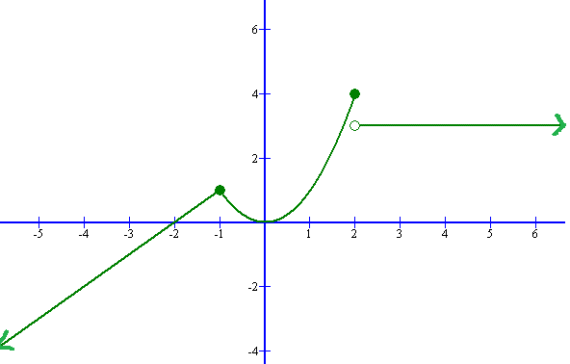
  - Find
  - Find
  - Find
does not exist.
This is because

Problems #2-12: Evaluate the limit, if it exists. If you claim that is does not exist (DNE) then provide a valid argument to support your claim.

- , we begin to expect the limit DNE.
Conclusion | Thought Process
Therefore, does not exist.
- Therefore,

This problem could also be done by multiplying by the conjugate .
- (Hint: If what can you say about the value of ?)
If then . We can use this to make a substitution.

- Consider the function.
- Find and .
- Does exist?
Yes, the limit exists.
Since we know that .
- Find and .
- Does exist?
No, the limit does not exist.
Since we know that does not exist.
- Consider the function.

- Find .
We can check this limit directly since is not a potential break point of the graph.

- Find .
We should check the limit from both sides, since a potential break occurs at . We see that
&
Therefore, since we know that .

- Use the Squeeze Theorem to help determine the following limit: .
By properties of the cosine function, we know that .
Therefore, .
Since and , then by the Squeeze Theorem .

- Use the Squeeze Theorem to help determine the following limit: .

By properties of the sine function, we know that .
Therefore, .
Therefore, .
Therefore, .

Since and , then by the Squeeze Theorem .

